Republic of the Philippines BARANGAY CULIAT
District VI, Quezon City Tel. No. 475-78-73

{full_name}
Address: {full_address} Culiat, QC Birth Date: {birth_date_short} Gender: {gender}
Status: {civil_status} Residency: {residency_type} Precinct No: {precinct_no} SSS/GSIS No: {sss_gsis_no} Tin No: {tin_no}
SA BRGY. CULIAT SERBISYO AY TAPAT LUNES HANGGANG LINGGO TULOY-TULOY ANG SERBISYO





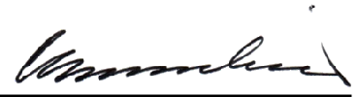
ID No: {id_number}

Signature
The Cardholder whose name, and photo appear on this card is bonafide resident of this barangay.

In case of loss of this card, please notify Barangay Administration Office and apply for a replacement. The same charges shall apply.

Date of Issue: {issue_date_short}
Date of Expiration: {expiration_date} CRISTINA V. BERNARDINO
Punong Barangay
IN CASE OF EMERGENCY PLEASE NOTIFY:
Name: {emergency_contact_name} Relationship: {emergency_contact_relationship} Contact No: {emergency_contact_number}
Address: {emergency_contact_address}

